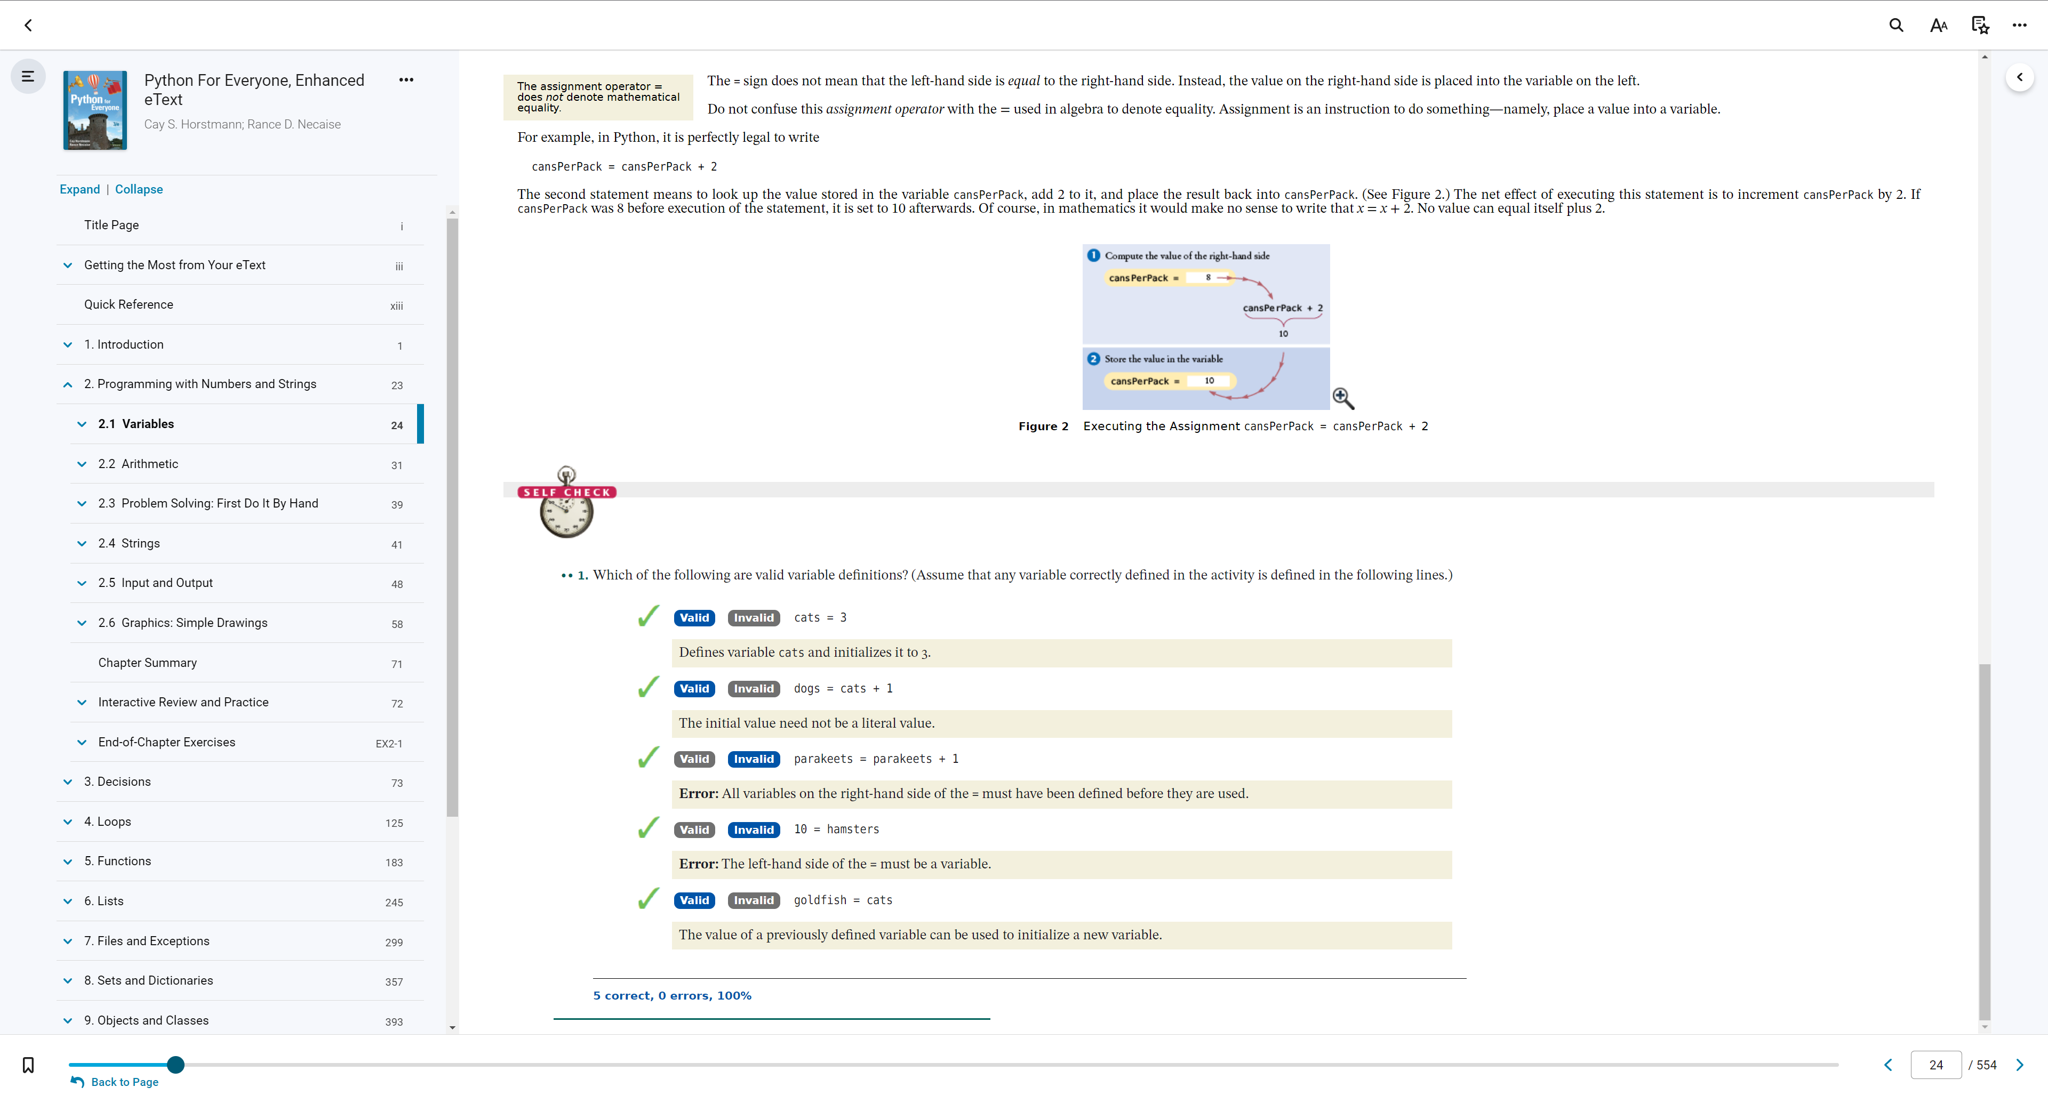

2.1

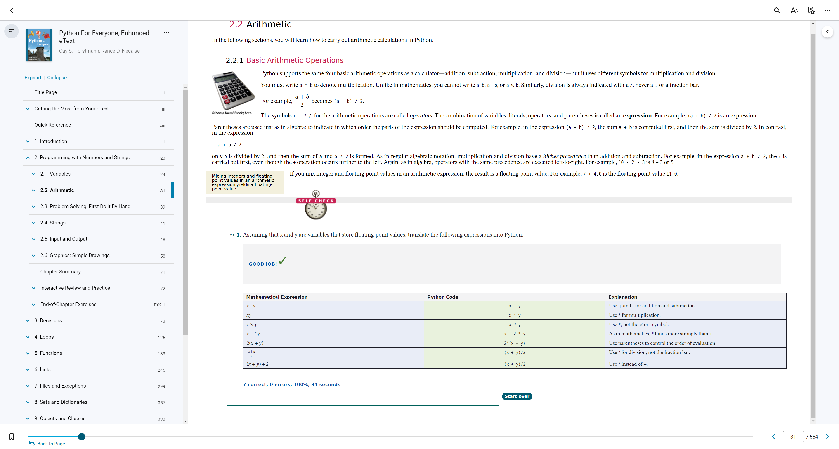

2.2

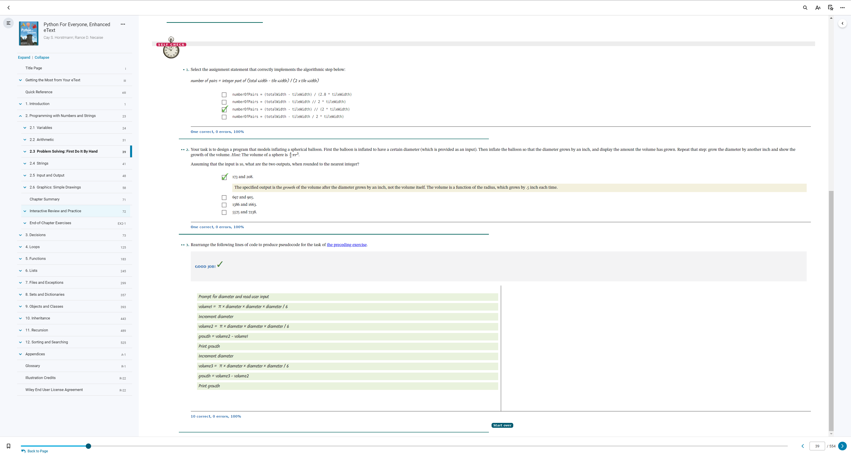

2.3

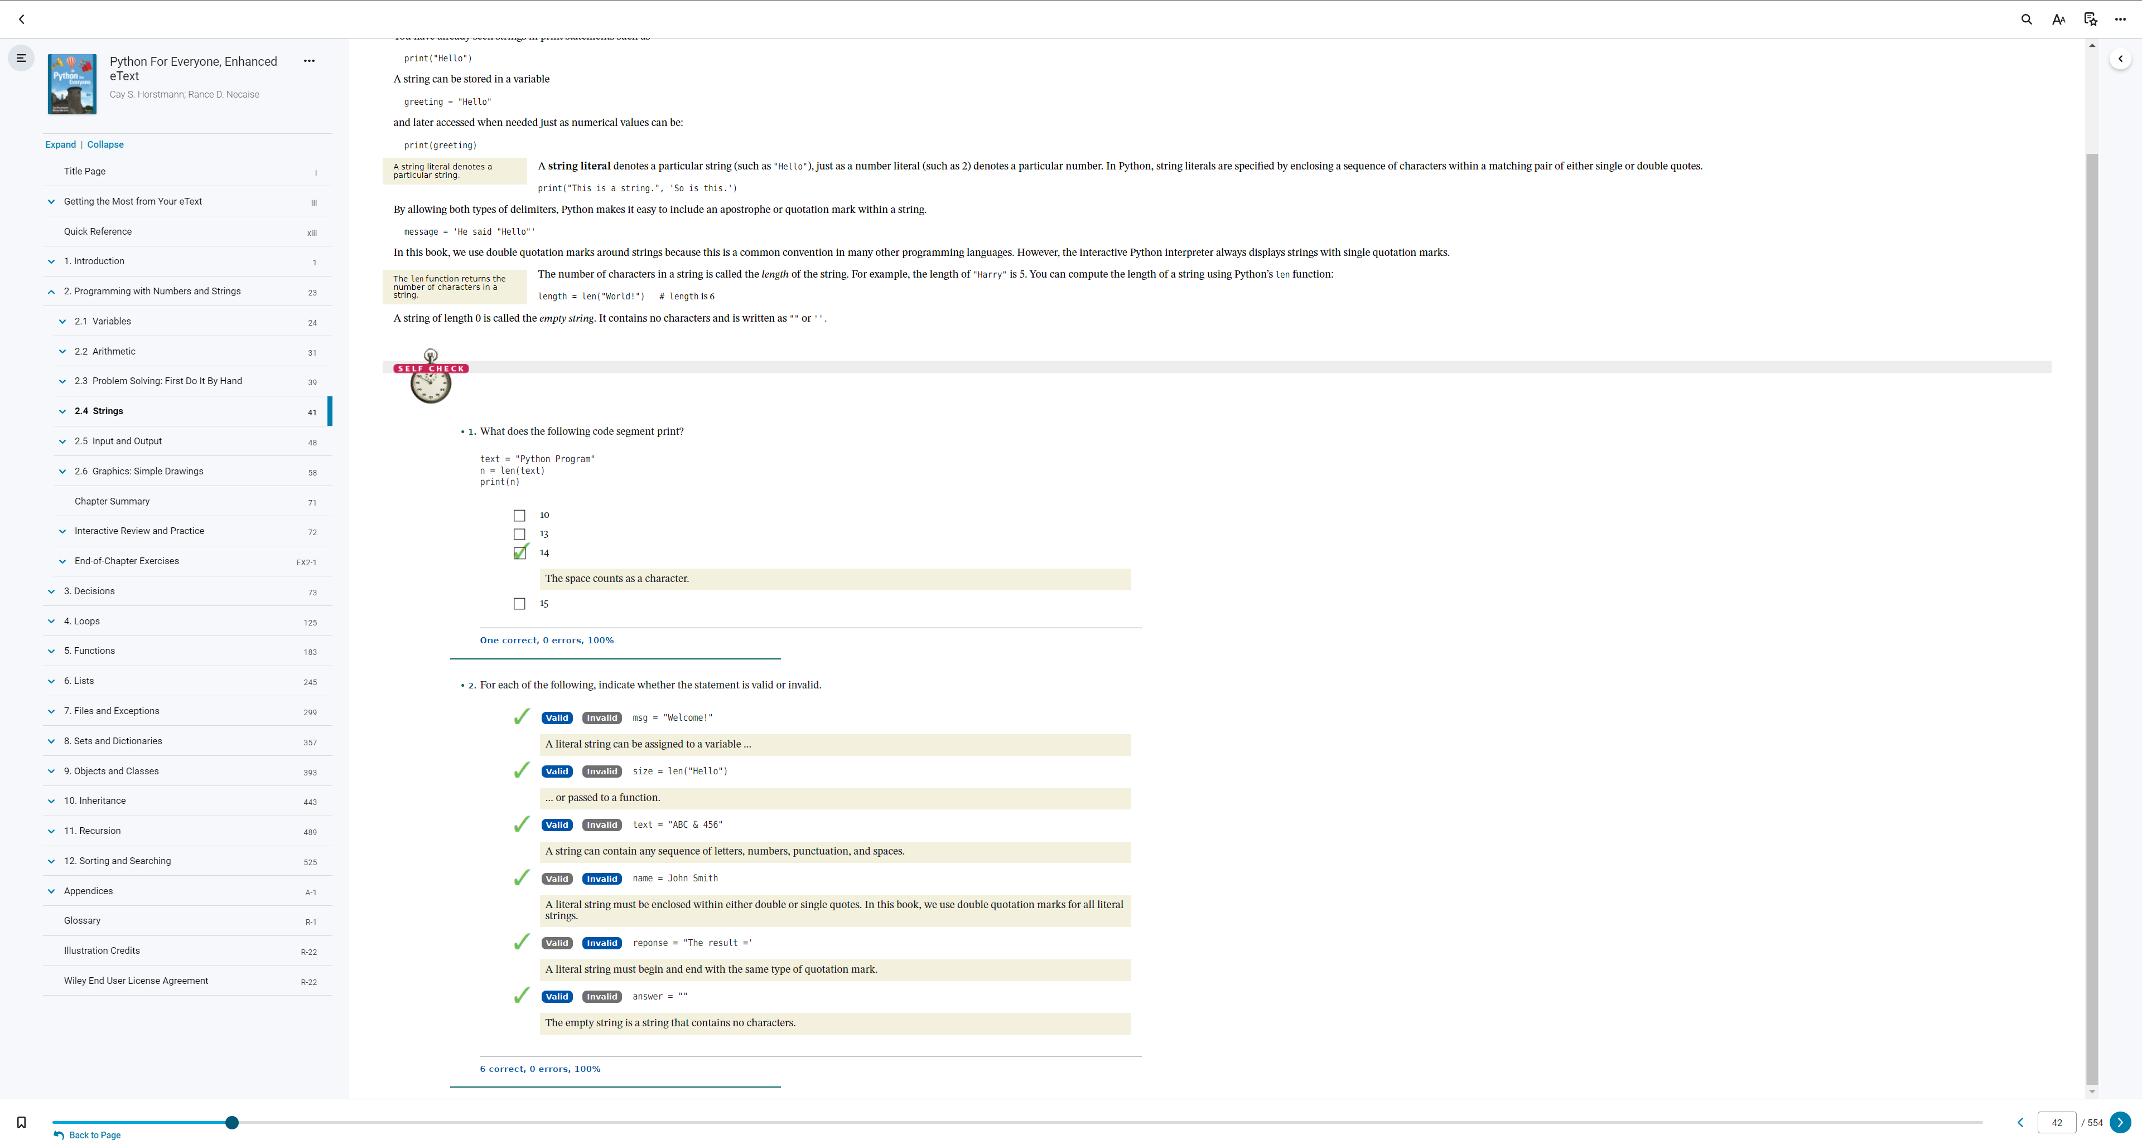
2.4

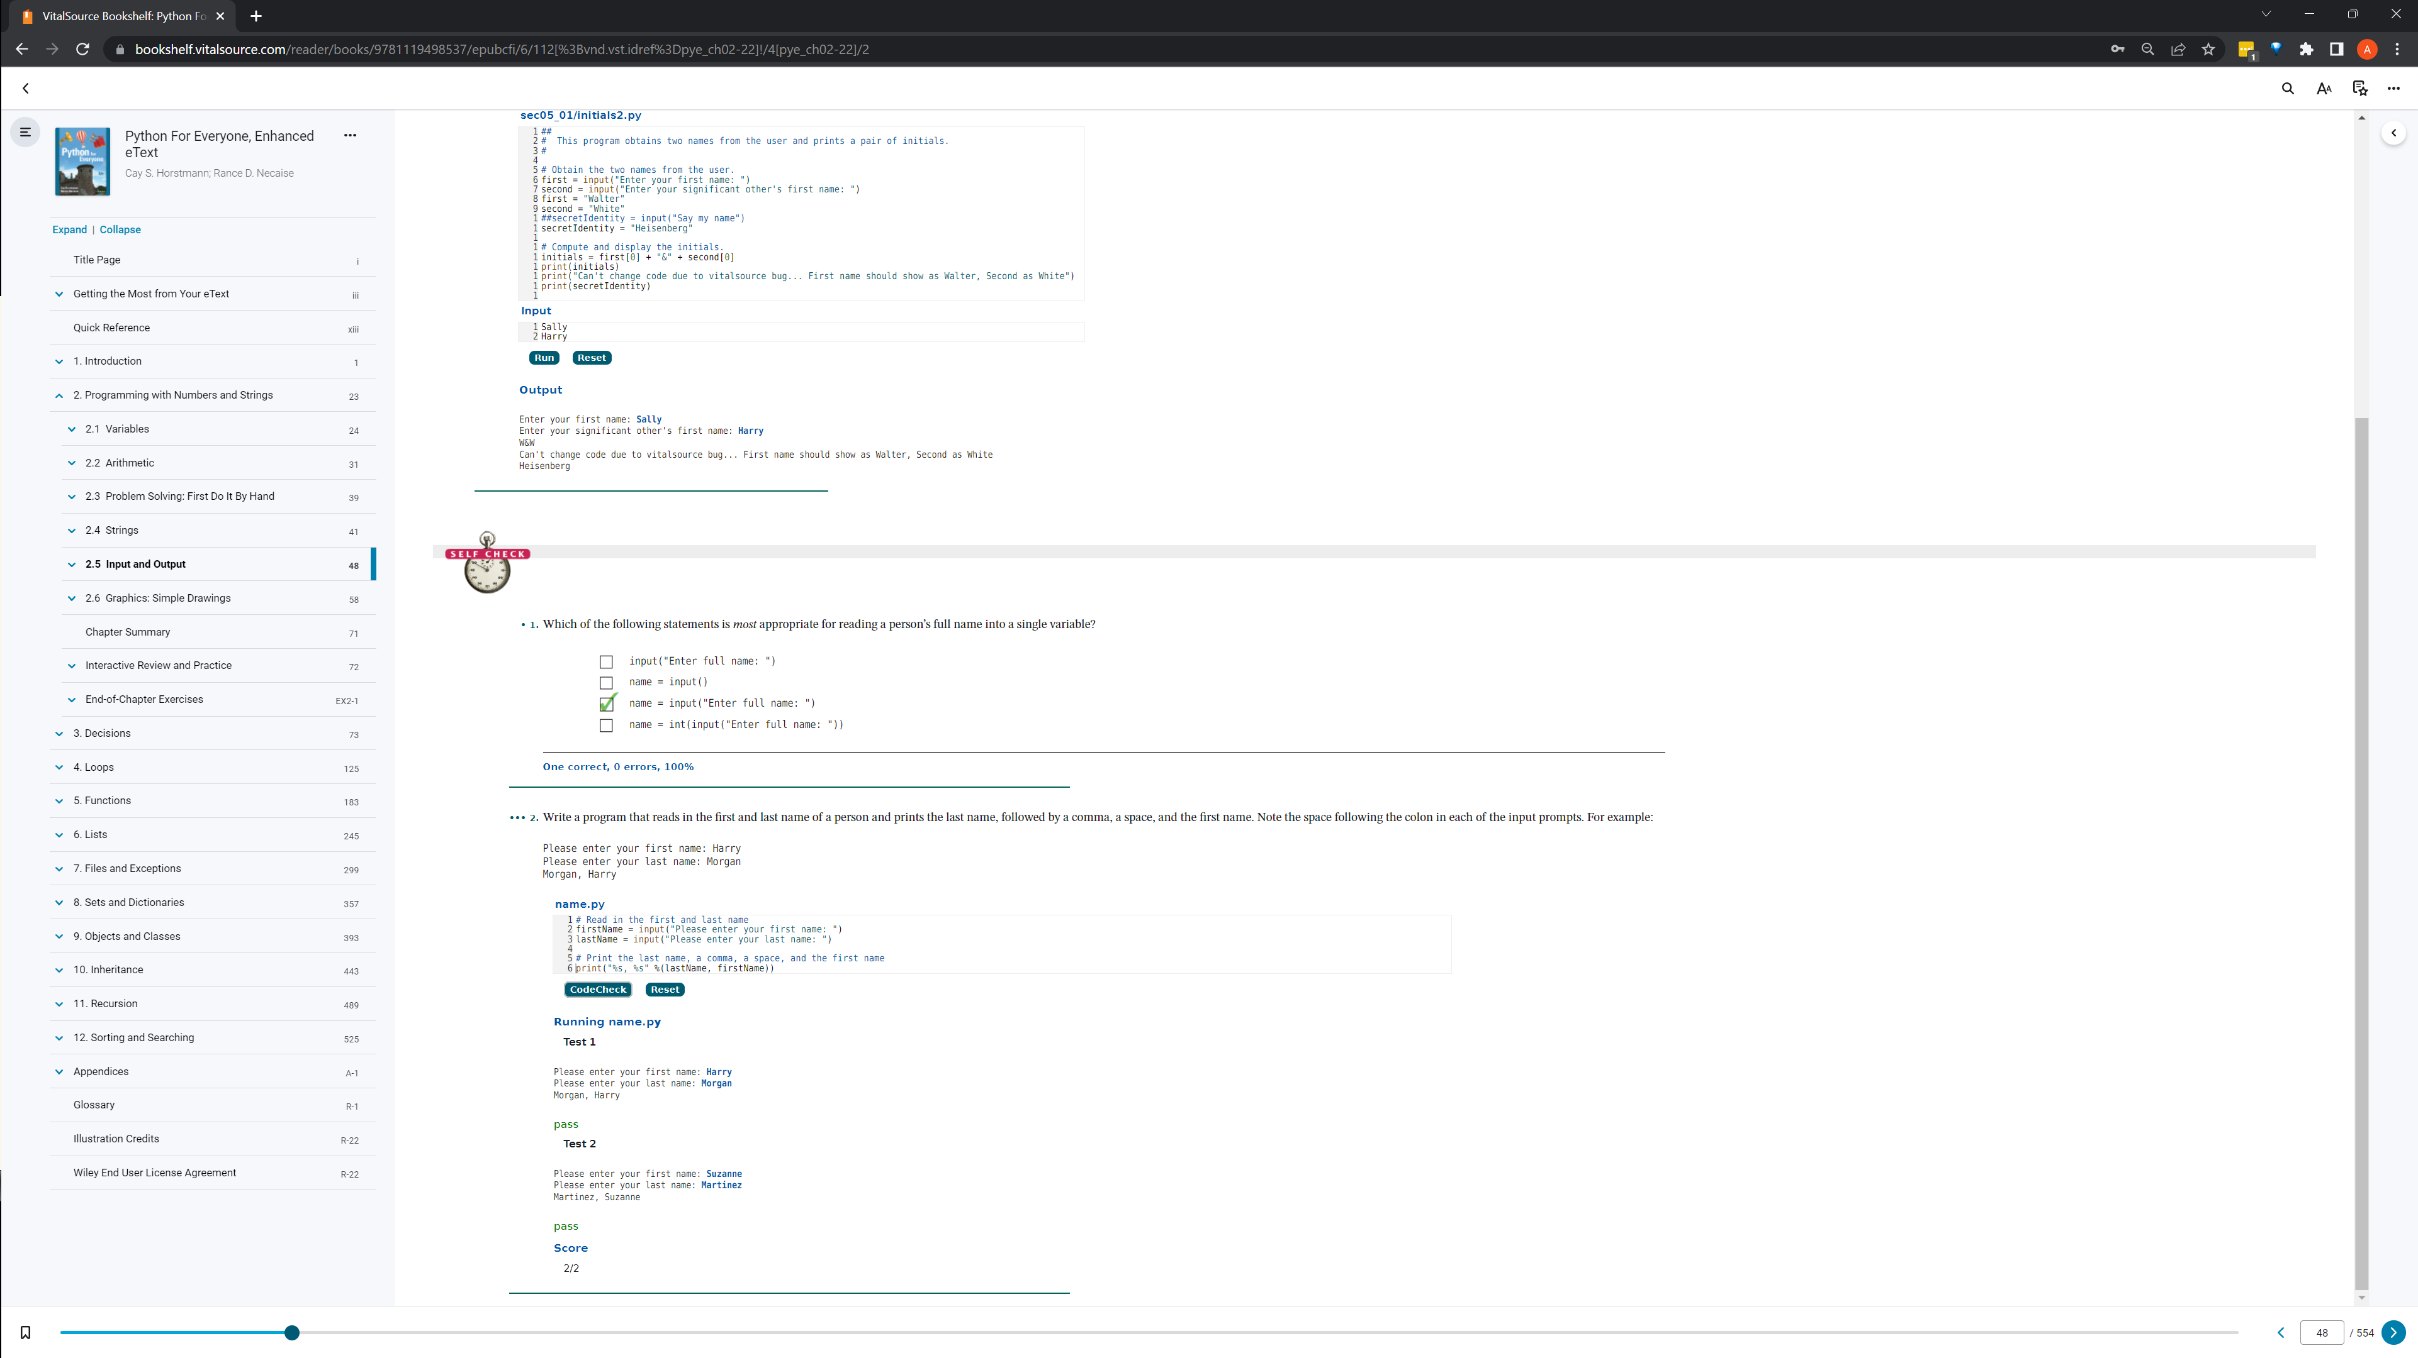

2.5

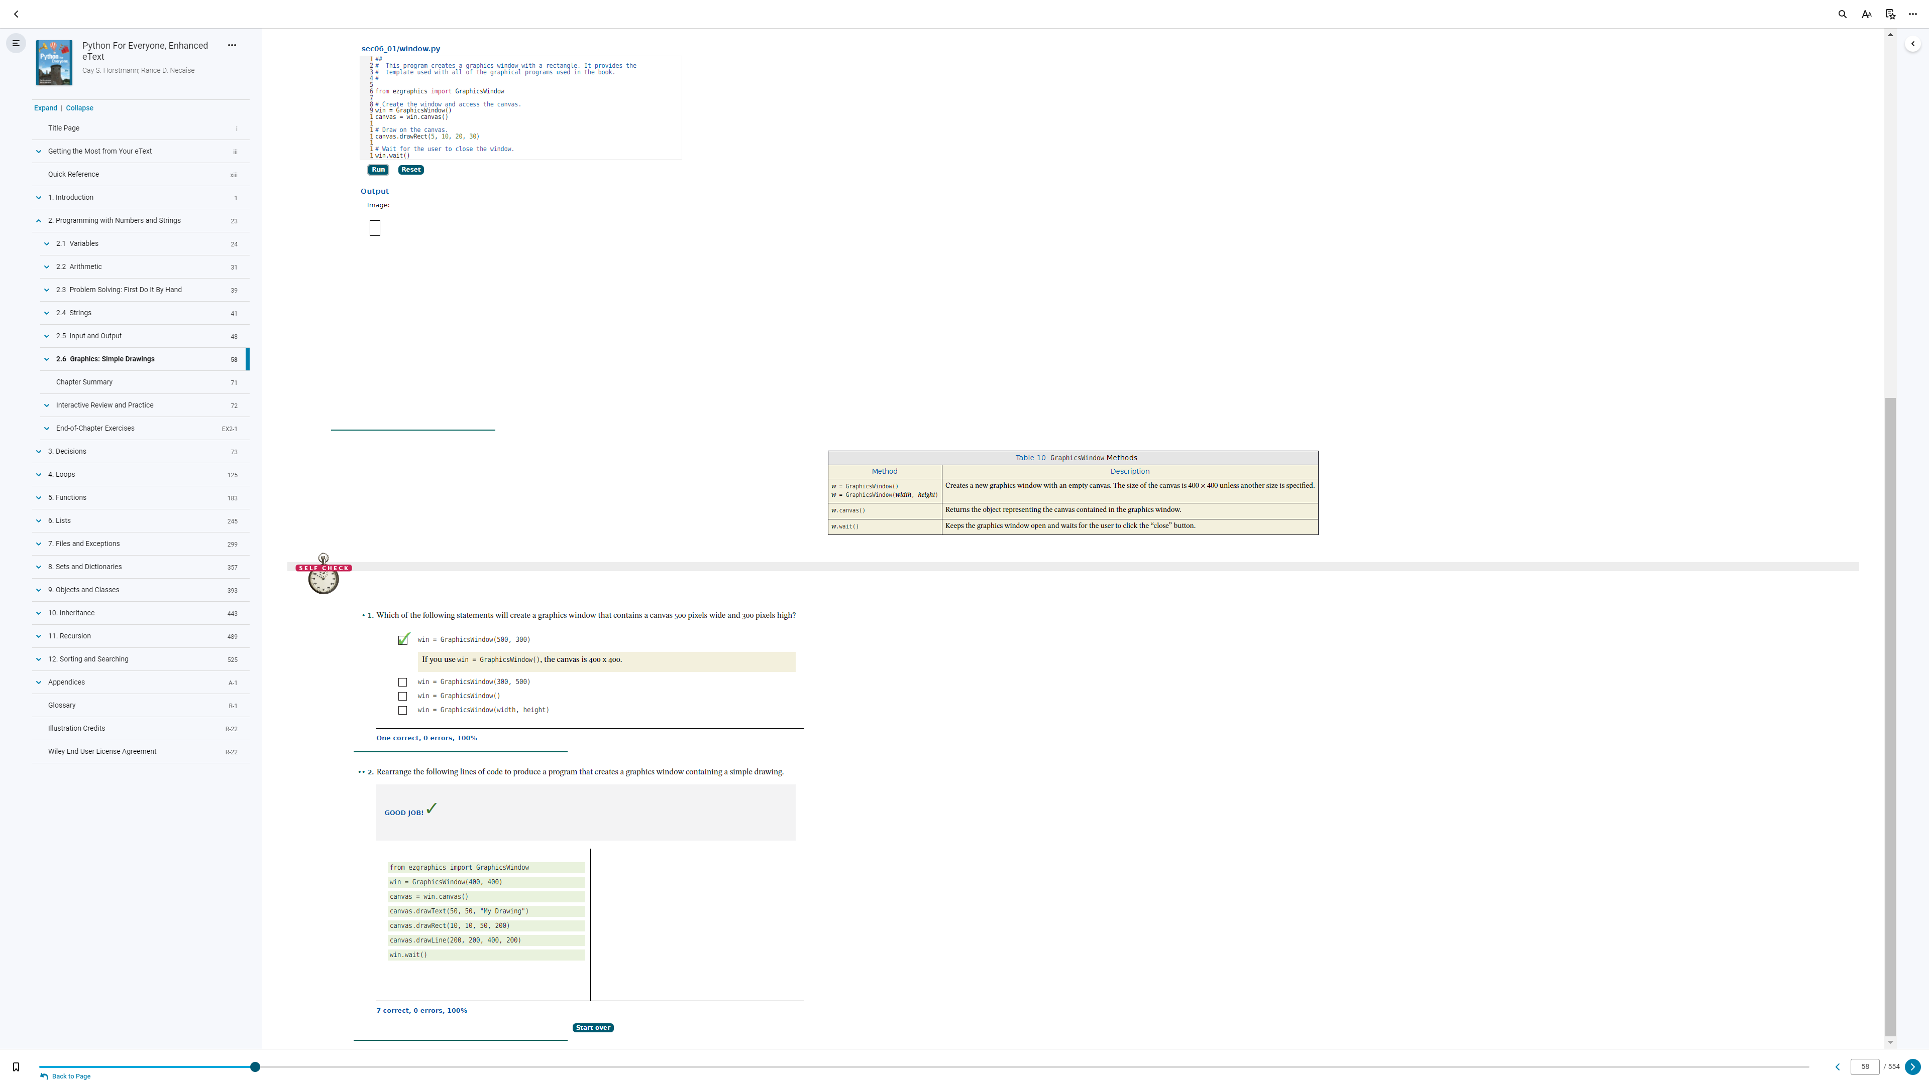

2.6

2.1 - Variables
2.2 - Arithmetic
2.3 - Problem Solving: First Do it By Hand
2.4 - Strings
2.5 - Input and Output
2.6 - Graphics: Simple Drawings (Optional)

